# KCE GUIDE

**A MINIPROJECT REPORT**

***Submitted by***

# ARUNESAN 20P205

# CHIDHAMBARAM 20P210

# DHARANESH 20P212

# PRAVEEN KUMAR 20P235

***in partial fulfilment for the award of the degree of***

# BACHELOR OF ENGINEERING

***in***

# COMPUTER SCIENCE AND ENGINEERING



**JANUARY 2022**



# KCE GUIDE

**Bonafide record of work done by**

# ARUNESAN 20P205

# CHIDHAMBARAM 20P210

# DHARANESH 20P212

# PRAVEEN KUMAR 20P235

Dissertation submitted in partial fulfilment of the requirements for the degree of

**BACHELOR OF ENGINEERING COMPUTER SCIENCE AND ENGINEERING**

# [JANUARY 2022]

...……………………… …………..……………….

## [Mr.VENKATESH(AP/CSE) ] [DR.T.Ravichandran

## Prof&HOD/CSE]

Faculty guide Head of the Department



Certified that the candidate was examined in the viva-voce examination held on

………………….

…………………………..

(Internal Examiner)

# TABLE OF CONTENTS

|  |  |  |
| --- | --- | --- |
| **CHAPTER.NO** | **CONTENTS** | **PAGE NO** |

|  |  |  |
| --- | --- | --- |
|  | **ABSTRACT** | 1 |
|  |  |  |
| **1** | **INTRODUCTION** | 2 |
|  | 1.1.Introduction to html |  |
|  | 1.2.Introduction to css |  |
| **2** | **SYSTEM OVERVIEW** | 3 |
|  | 2.1.Existing System |  |
|  | 2.2.Proposed System |  |
| **3** | **SYSTEM REQUIREMENTS** | 4 |
|  | 3.1.Hardware and Software requirements |  |
|  | 3.2.Technology Used |  |
| **4** | **MODULES** | 5 |
|  | 4.1. List Of modules |  |
|  | 4.2 Description Of Modules |  |
| **5** | **SOURCE CODE** | 8 |
| **6** | **QR CODE** | 14 |
| **7** | **CONCLUSION AND REFERENCES** | 15 |

**ABSTRACT:**

To guide new peoples to know about our college and for the freshers who join new to our college.This information helps the people to find the desired locations to visit. This project is mainly beneficial for the students having no idea about the places they want to visit in our campus.People can find this information through QRcode or Link that get paste in the enterance they can scan the code and see the places they need.

1. **INTRODUCTION**

# INTRODUCTION TO HTML:

The HyperText Markup Language or HTML is the standard markup language for documents designed to be displayed in a web browser .It can be assisted by technologies such as Cascading Style Sheets.It is the skeleton of our webpage .We have used html for the basic navigation in the page .

# INTRODUCTION TO CSS:

Cascading Style Sheets is a style sheet language used for describing

the Presentation of a document written in a markup language such as

HTML or XML .CSS is a cornerstone technology of the World Wide Web .

We have used css for customization of the webpage alongside with html .

# SYSTEM OVERVIEW

## EXISTING SYSTEM

Creation of GUIDING

## Drawbacks:

Requires good internet

## PROPOSED SYSTEM

Provides location for existance of labs,rooms in our campus.

**Advantages:**

Reduce time

# SYSTEM REQIREMENTS

## SOFTWARE AND HARDWARE REQIREMENTS

* + - * + Mobile device **-**  Operating System Android(>10)
        + Good internet connection

## TECHNOLOGIES USED

* HTML
* CSS
* PHP

# MODULES

* 1. **LIST OF MODULES:**
     + Home Page
     + Content
     + Destination

# DESCRIPTION OF MODULES:

## Homepage:

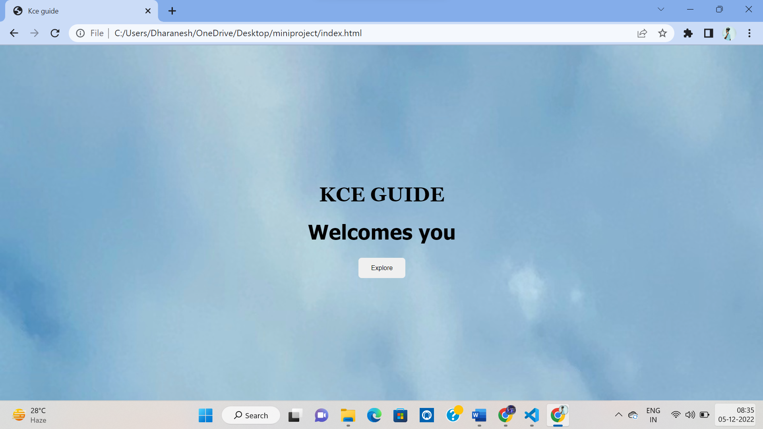

## Content page:

## 

## 

## 

**Destination:**

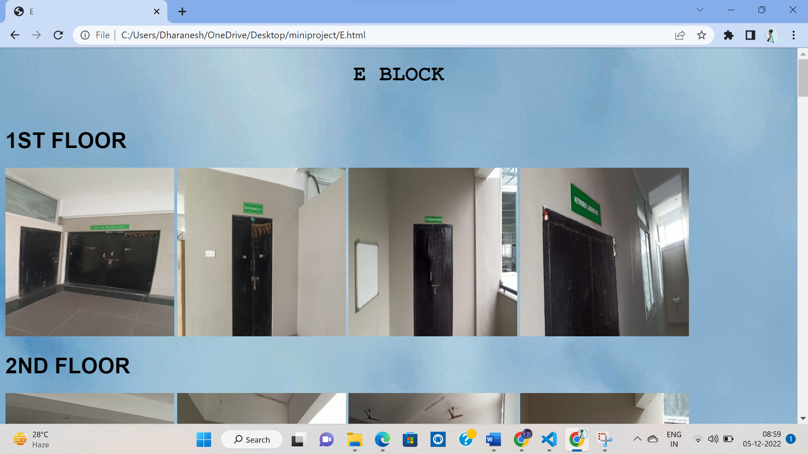

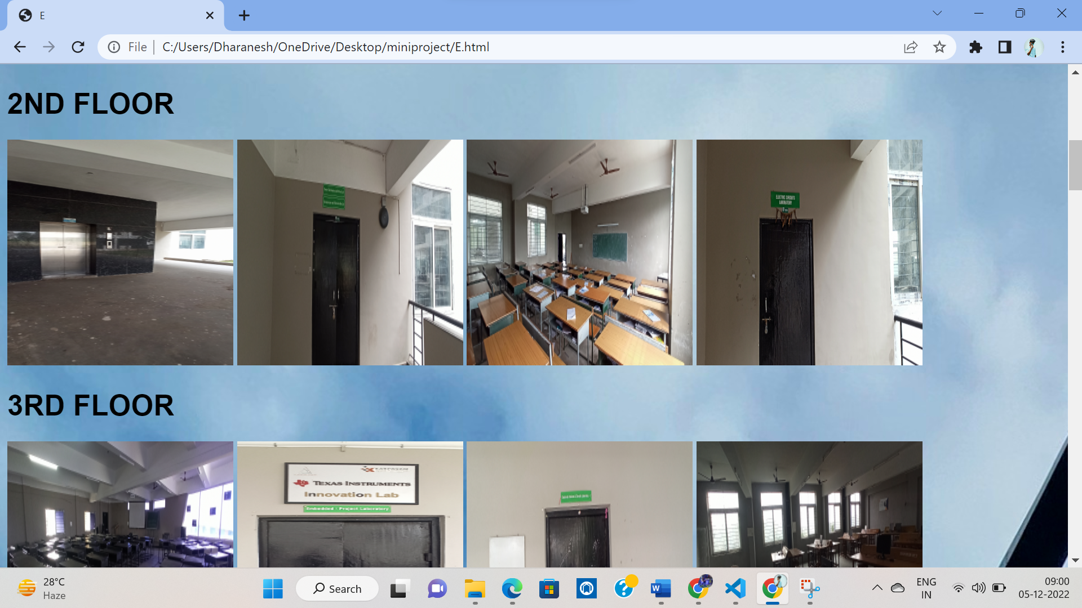

## SOURCE CODE:

## INDEX.HTML

<!DOCTYPE html>

<html lang="en">

<head>

    <meta charset="UTF-8">

    <meta http-equiv="X-UA-Compatible" content="IE=edge">

    <meta name="viewport" content="width=device-width, initial-scale=1.0">

    <title>Kce guide</title>

    <link rel="stylesheet" href="https://cdn.jsdelivr.net/npm/@fortawesome/fontawesome-free@6.2.0/css/fontawesome.min.css" integrity="sha384-z4tVnCr80ZcL0iufVdGQSUzNvJsKjEtqYZjiQrrYKlpGow+btDHDfQWkFjoaz/Zr" crossorigin="anonymous">

    <link rel="stylesheet" href="style.css">

</head>

<body >

    <div class="header">

        <h1 style="font-family:Georgia;">KCE GUIDE</h1>

        <h1 style="font-family:tahoma;">Welcomes you</h1>

        <button class="btn"><a href="content.html">Explore</a</button>

    </div>

</body>

</html>

**CONTENT.HTML**

<!DOCTYPE html>

<html lang="en">

<head>

    <meta charset="UTF-8">

    <meta http-equiv="X-UA-Compatible" content="IE=edge">

    <meta name="viewport" content="width=device-width, initial-scale=1.0">

    <!-- CSS only -->

<link href="https://cdn.jsdelivr.net/npm/bootstrap@5.2.3/dist/css/bootstrap.min.css" rel="stylesheet" integrity="sha384-rbsA2VBKQhggwzxH7pPCaAqO46MgnOM80zW1RWuH61DGLwZJEdK2Kadq2F9CUG65" crossorigin="anonymous">

    <link rel="stylesheet" href="style.css">

    <title>content</title>

</head>

<body>

    <br>

    <h1 class="heading" style="font-family:impact;">Choose your Destination</h1>

    <div class="block">

        <div class="col"

         <a href="A.html"><img src="Ablock.jpg" alt="Ablock"  height=200px width=100px></a>

            <button class="btn" value="click"><a href="A.html">A BLOCK</a></button>

        </div>

        <div class="col">

          <a href="C.html"> <img src="Cblock.jpg" alt="Cblock"  height=200px width=100px></a>

          <button class="btn" value="click"><a href="C.html">C BLOCK</a></button>

        </div>

        <div class="col">

               <a href="M.html"><img src="Mblock.jpg" alt="Mblock"  height=200px width=100px></a>

               <button class="btn" value="click"><a href="M.html">M BLOCK</a></button>

        </div>

        <div class="col">

            <a href="D.html"><img src="Dblock.jpg" alt="Dblock"  height=200px width=100px></a>

            <button class="btn" value="click"><a href="D.html">D BLOCK</a></button>

        </div>

        <div class="col">

            <a href="E.html"><img src="Eblock.jpg" alt="Eblock"  height=200px width=100px></a>

            <button class="btn" value="click"> <a href="E.html">E BLOCK</a></button>

        </div>

        <div class="col">

            <a href="B.html"><img src="MBA.jpg" alt="MBA"  height=200px width=100px></a>

            <button class="btn" value="click"> <a href="B.html">B BLOCK</a></button>

        </div>

        <div class="col">

            <a href="lib.html"><img src="library.png" alt="Library"  height=200px width=100px></a>

            <button class="btn" value="click"><a href="lib.html">LIB </a></button>

        </div>

        <div class="col">

            <a href="Amt.html"><img src="Amphitheatre.jpg" alt="Amphitheatre"  height=200px width=100px></a>

            <button class="btn" value="click"><a href="Amt.html">AMT </a></button>

        </div>

        <div class="col">

            <a href="Aud.html"><img src="Auditorium.jpg" alt="Auditorium"  height=200px width=100px></a>

            <button class="btn" value="click"> <a href="Aud.html">AUD </a></button>

        </div>

    </div>

</body>

**STYLE.CSS**

body{

    background-image: url(frontpg.jpg);

    margin:0;

    padding:0;

    box-sizing: border-box;

}

.title{

    margin-top:18%;

    font-size: 40px;

    text-align: center;

}

.header{

    text-align: center;

    color:black;

    margin-top: 18%;

}

.heading{

    text-align: center;

    margin-bottom: 50px;

}

a:link,a:visited{

 text-decoration: none;

 display: inline-block;

 color:black;

}

.block{

    display:block;

    display:grid;

    grid-template-columns: repeat(3,100px);

    grid-gap: 20px;

    justify-content:center;

}

  @media(min-width:750px){

    .col{

        display:block;

        display:grid;

        grid-template-columns: repeat(1,100px);

        justify-content:center;

    }

}

.btn{

   border-radius:5px;

   border:none;

   padding:10px 20px;

   font-size: 10px;

}

.btn:hover{

    background-color: rgb(0, 162, 255);

}

.letter{

   position:absolute;

   padding:50px 40px;

   color:black;

}

img{

    opacity:0.5;

}

.A{

    align-items: center;

    display:inline-block;

}

.B{

    align-items: center;

    display:inline-block;

}

.C{

    align-items: center;

    display:inline-block;

}

.D{

    align-items: center;

    display:inline-block;

}

<!DOCTYPE html>

<html lang="en">

<head>

    <meta charset="UTF-8">

    <meta http-equiv="X-UA-Compatible" content="IE=edge">

    <meta name="viewport" content="width=device-width, initial-scale=1.0">

    <title>E</title>

</head>

<body style="background-image: url(frontpg.jpg);">

    <h1 style="text-align:center; font-family: 'Courier New', Courier, monospace;">E BLOCK</h1> <br>

    <h1 style="text-align:left; font-family:Arial, Helvetica, sans-serif;">1ST FLOOR</h1>

    <img class="A" src="e1.jpg" alt="" height="250px" width="250px">

    <img class="A" src="e2.jpg" alt=""height="250px" width="250px">

    <img class="A" src="e3.jpg" alt=""height="250px" width="250px">

    <img class="A" src="e4.jpg" alt=""height="250px" width="250px">

<img class="A" src="e5.jpg" alt=""height="250px" width="250px">

    <h1 style="text-align:left; font-family:Arial, Helvetica, sans-serif;">2ND FLOOR</h1>

    <img class="A" src="e6.jpg" alt=""height="250px" width="250px">

    <img class="A" src="e7.jpg" alt=""height="250px" width="250px">

    <img class="A" src="e8.jpg" alt=""height="250px" width="250px">

    <img class="A" src="e9.jpg" alt=""height="250px" width="250px">

    <h1 style="text-align:left; font-family:Arial, Helvetica, sans-serif;">3RD FLOOR</h1>

    <img class="A" src="e11.jpg" alt=""height="250px" width="250px">

    <img class="A" src="e12.jpg" alt=""height="250px" width="250px">

    <img class="A" src="e13.jpg" alt=""height="250px" width="250px">

    <img class="A" src="e14.jpg" alt=""height="250px" width="250px">

<img class="A" src="e15.jpg" alt=""height="250px" width="250px">

    <h1 style="text-align:left; font-family:Arial, Helvetica, sans-serif;">4TH FLOOR</h1>

    <img class="A" src="e16.jpg" alt=""height="250px" width="250px">

    <img class="A" src="e17.jpg" alt=""height="250px" width="250px">

    <img class="A" src="e18.jpg" alt=""height="250px" width="250px">

    <img class="A" src="e19.jpg" alt=""height="250px" width="250px">

    <img class="A" src="e20.jpg" alt=""height="250px" width="250px">

    <h1 style="text-align:left; font-family:Arial, Helvetica, sans-serif;">5TH FLOOR</h1>

    <img class="A" src="e21.jpg" alt=""height="500px" width="500px">

    <img class="A" src="e22.jpg" alt=""height="500px" width="500px">

    <img class="A" src="e23.jpg" alt="" height="500px" width="500px">

    <img class="A" src="e24.jpg" alt=""height="500px" width="500px">

    <img class="A" src="e25.jpg" alt=""height="500px" width="500px">

    <img class="A" src="e26.jpg" alt=""height="500px" width="500px">

    <img class="A" src="e27.jpg" alt=""height="500px" width="500px">

    <img class="A" src="e28.jpg" alt=""height="500px" width="500px">

    <img class="A" src="e29.jpg" alt=""height="500px" width="500px">

    <img class="A" src="e30.jpg" alt=""height="500px" width="500px">

    <img class="A" src="e31.jpg" alt=""height="500px" width="500px">

</body>

</html>

This the code similar to all blocks….

# QR CODE



**GITHUB LINK:**

**https://dharaneshpg.github.io/guidekce/**

# CONCLUSION:

Thus the app to create quiz is completed successfully.

# REFERENCES:

HTTPS://WWW.W3SCHOOLS.COM/HTML/HTML_CSS.ASP

HTTPS://WWW.QUORA.COM/HOW-CAN-I-MERGE-CSS-AND-HTML-CODES

HTTPS://WWW.MYINTERVALS.COM/EMOGRIFIER.PHP

HTTPS://WWW.MODPAGESPEED.COM/DOC/FILTER-CSS-COMBINE

HTTPS://WWW.CODECADEMY.COM/FORUM_QUESTIONS

HTTPS://DEVELOPPAPER.COM/FOUR-WAYS-OF-COMBINING-CSS-AND-HTML/